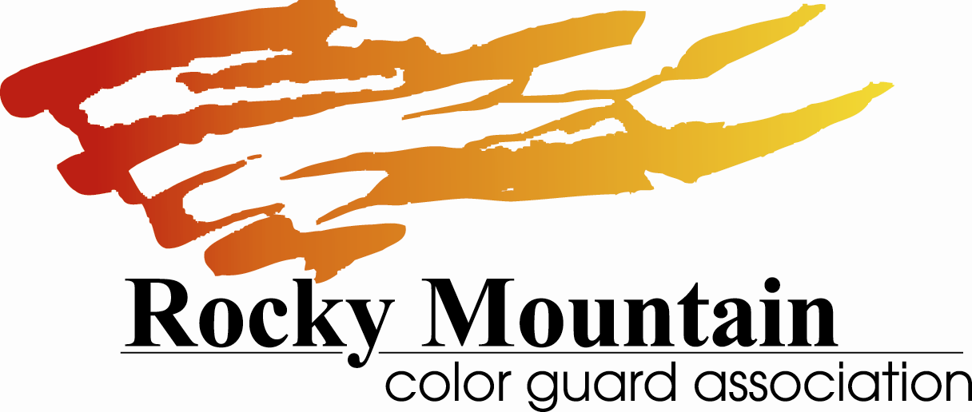

SCHOLASTIC CERTIFICATE
OF ELIGIBILITY

This form is to certify scholastic eligibility for students participating in Rocky Mountain Color Guard Association events. All performers of a competing group in any scholastic unit must be approved for participation by the principal/band director of the sponsoring school. Novice units must fall into the age category for that class/

Please fill out the information below and have an administrator from the high school unit sign the form. If you run out of spaces use a second form.

Unit: _____________________________________

Date: _______________________

Student Name | Grade | School Attending (Age for Novice units)

Coach Signature ________________________________________ Date _________________

Administrator Signature _________________________________ Date _________________

